Raspberry Pi – Cats! Projects

Objective: Using Scratch2 on the Raspberry Pi, create a game where the player must use a pencil to draw a path allowing the cats to cross the canyon to safety.

# Sprites

The first sprite used was a simple pencil that is already in the Scratch library

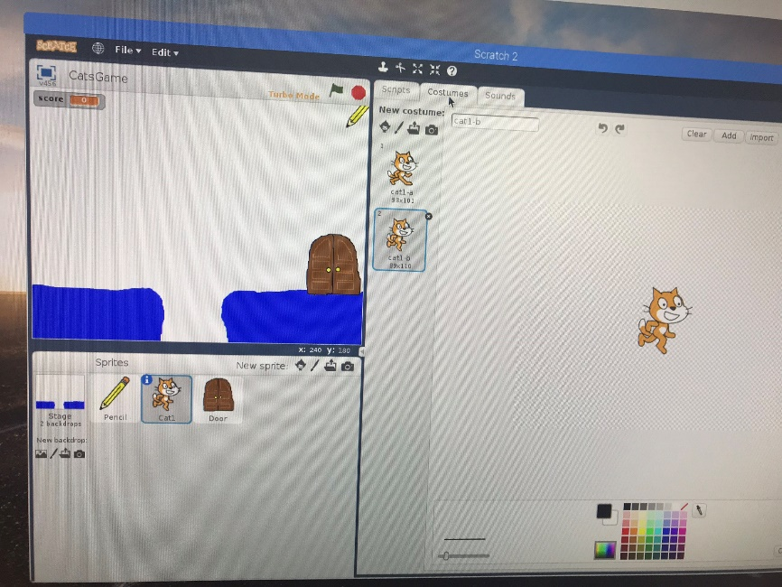

The next sprite was the cat, which actually had two costumes (both of which are included in the Scratch library)

The last sprite was the door, which did not exist in the library, so I had to draw it myself.

# Stage Backdrops

I also designed two backdrops for the stages

## Scripts

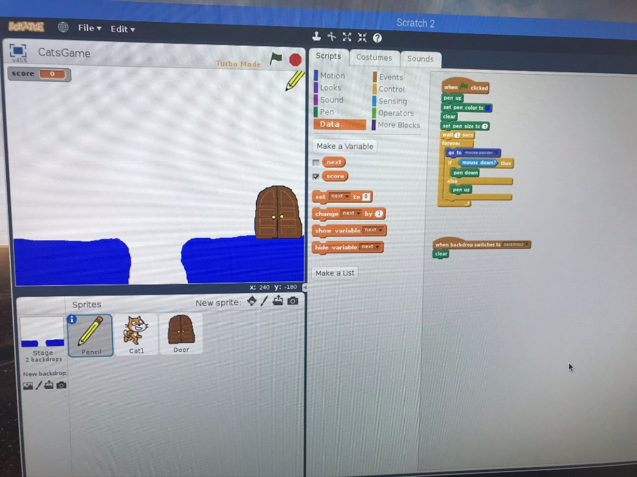Pencil:

This script gives the pencil functionality to draw blue lines when the mouse is clicked after starting the game, as well as clearing any previous markings

It also clears the screen when the game switches to the second stage

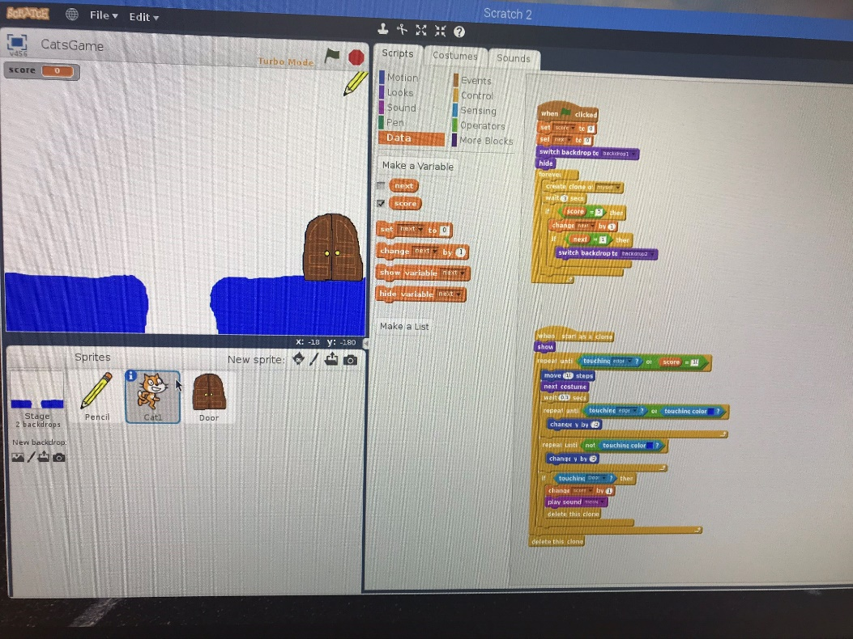The Cat

This script sets both variables (score and next) to 0 and starts a loop of cat clones. It also contains an if statement that switches to the second stage when the score is 5.

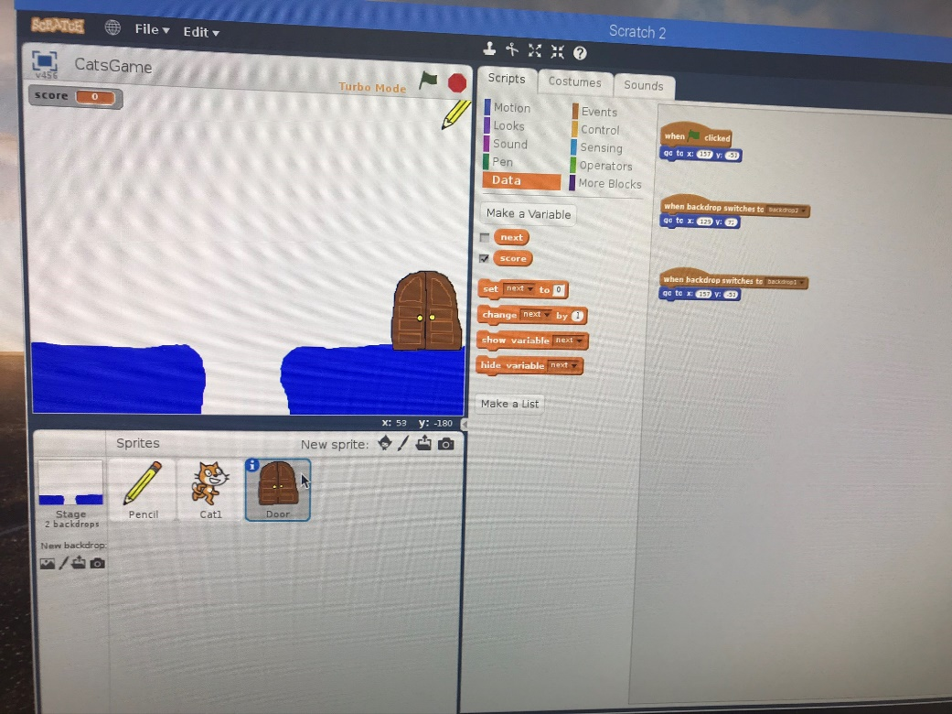The next script controls each cat’s movement and causes it to disappear upon touching an edge or the door. It also increments the score and meows when a cat reaches safety

These scripts set the door’s coordinates at the start, and when the stage changes.

# Running the Game

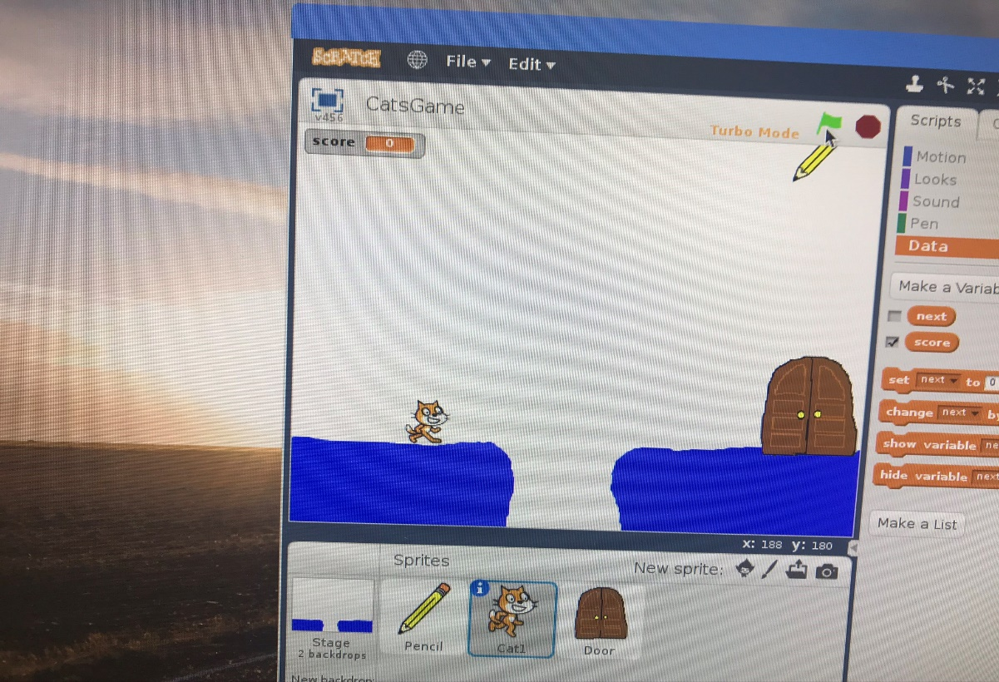When the game starts, cats start spawning on the top left corner and fall to the ground. Once on the ground, the cats will continue walking left until they reach the door or an edge, and will disapear. As the cats walk, the sprite switches between its costumes to create a walking animation.

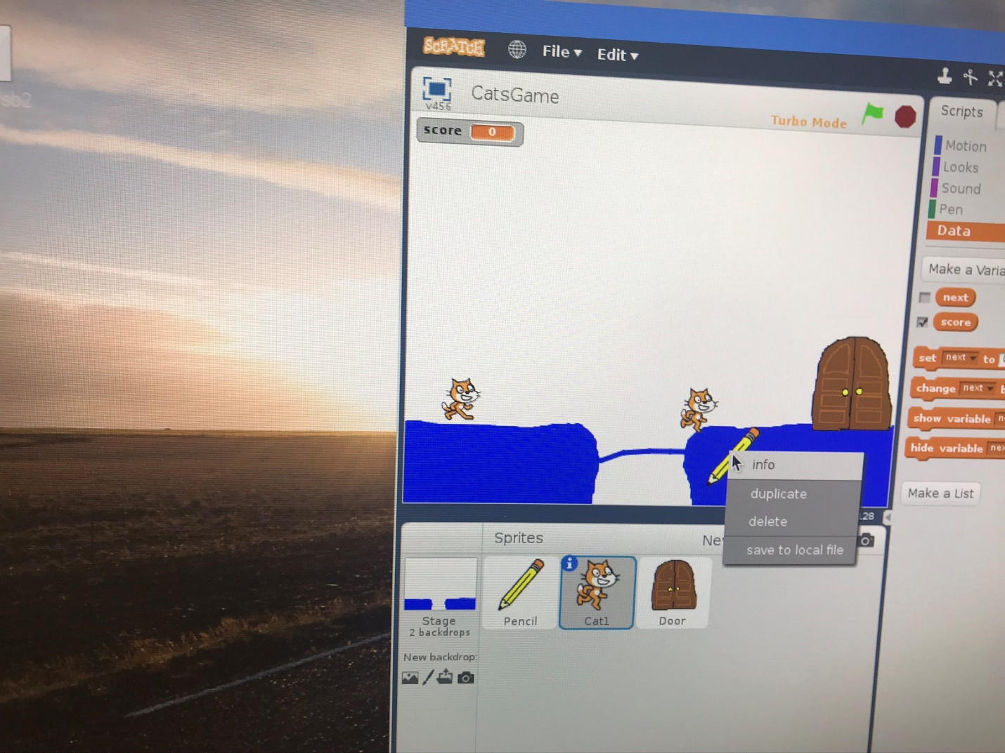By using the pencil, the player draws a blue line that the cat will walk on top of. If the cat comes in contact with blue other than below them, it will climb upwards until it is walking on top of it.

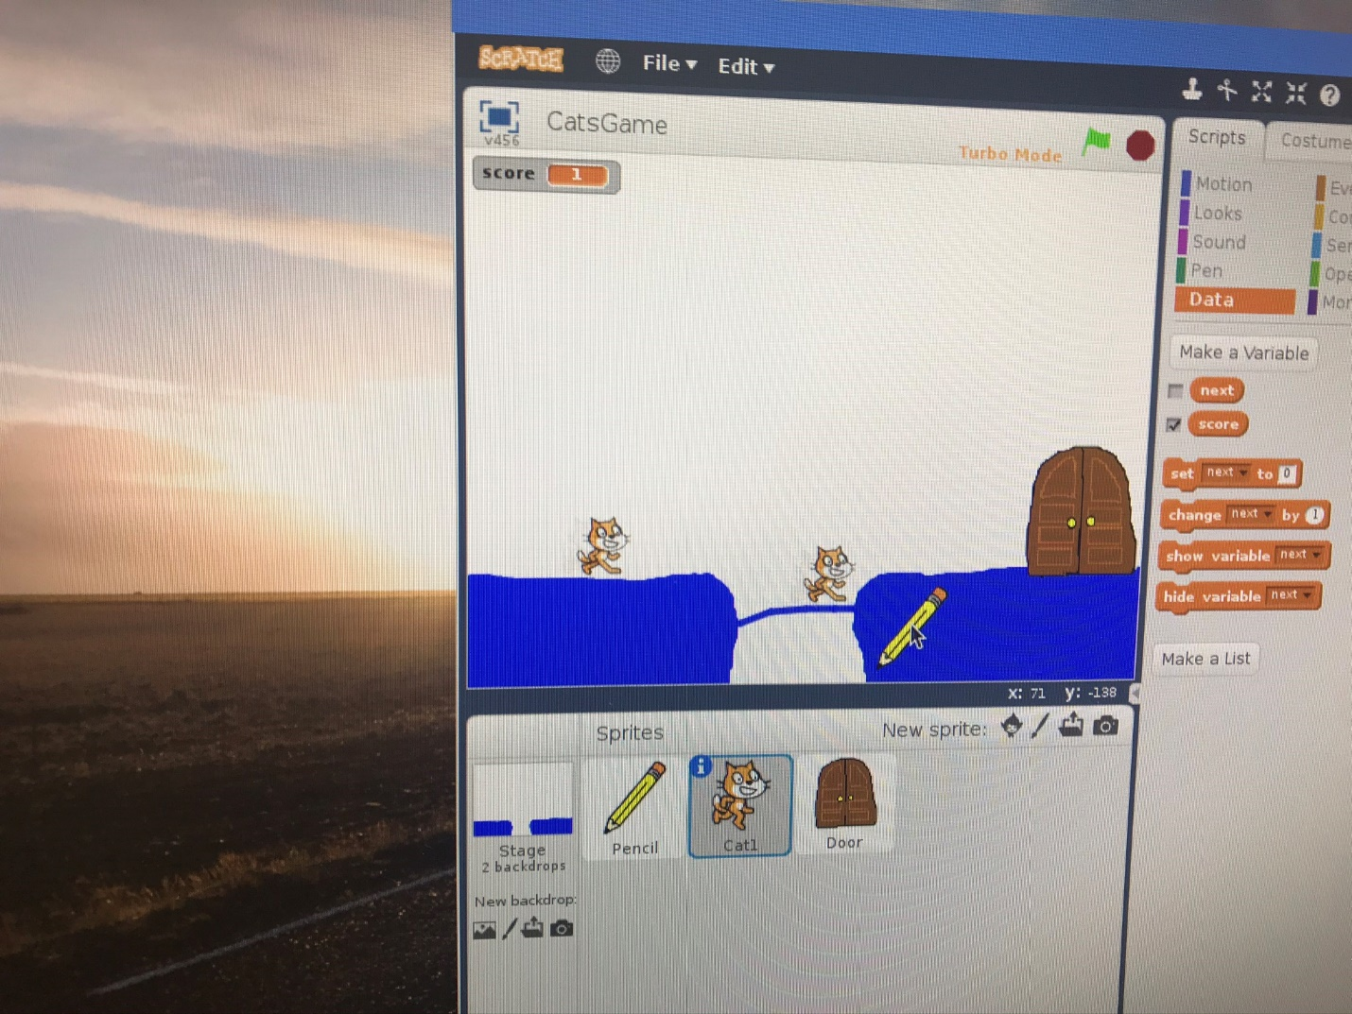 When a cat reaches the door, it disappears and the score in the top left increases by 1.

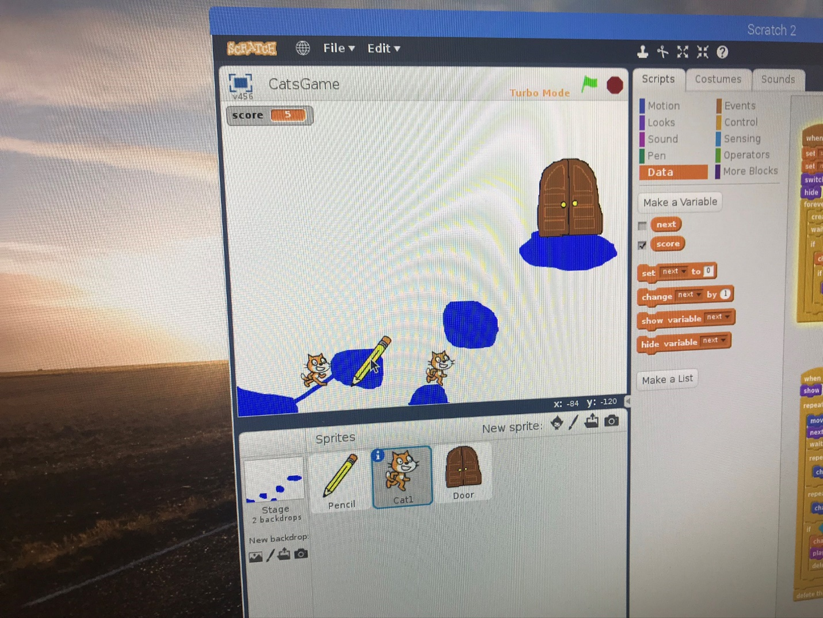

When the score reaches five, the backdrop switches, the door moves to its new location, and previous paths are cleared, but cats continue spawning.

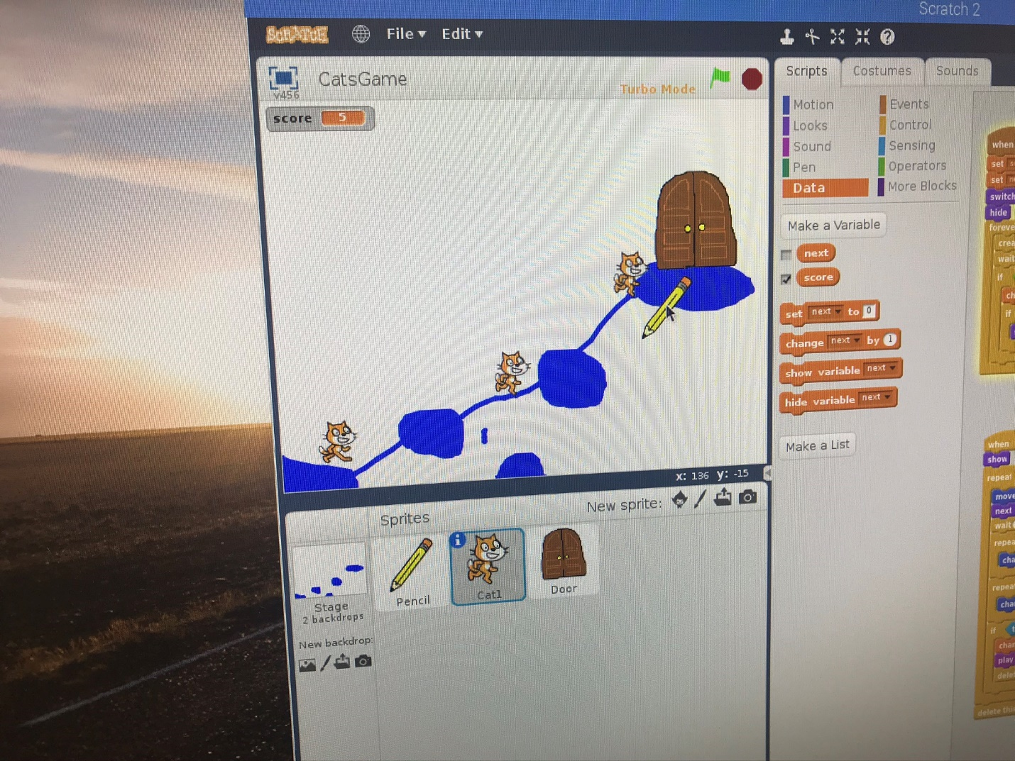The user draws a new path to the door, and guides the cats to saftey.

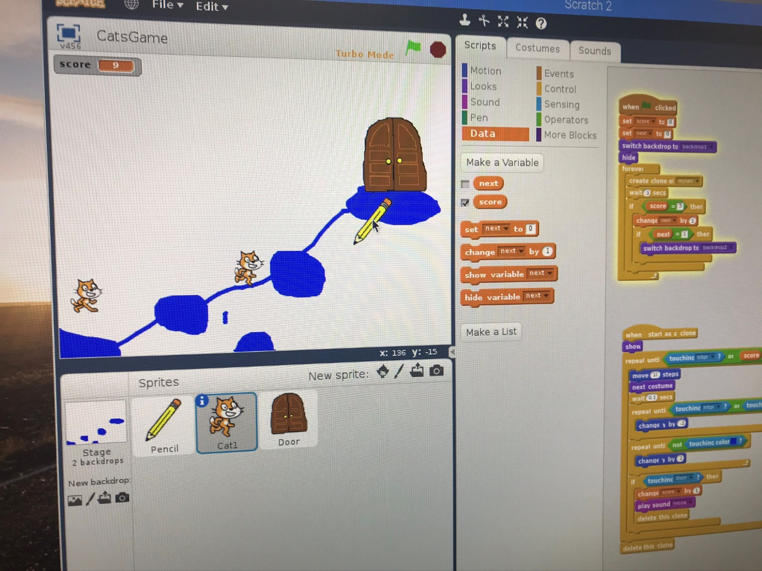

The score continues to increase as cats make their way to safety.

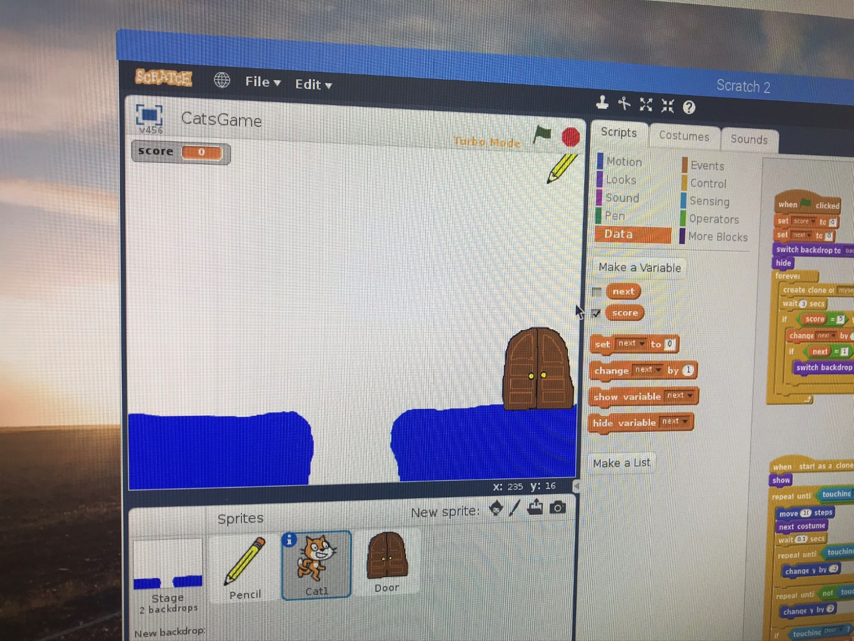

Once the score reaches 10, the game ends

## Challenges Encountered

Throughout this project I encountered multiple challenges that slowed my progress. The first of which was figuring out how to interface the raspberry pi with the correct hardware to actually use it. I was easily able to connect it to the projector in the lab, but it was difficult to work on. I also was able to display it through HDMI on my TV; however, I did not originally have a USB keyboard to actually work with. I ended up using the All-in-one’s in the computer lab, and I realized I just had to press the input button on the side to switch to HDMI IN.

Another issue I ran into was not being able to download the starter project off of the scratch website, due to a server error on their side. This didn’t have any major ramifications, other than the fact that I had to draw the backdrop and the door sprite on my own.

The project on the Raspberry Pi website only showed how to make one stage of the game, but I wanted the game to be slightly more complex. It took me a little bit to figure out how to make the game switch to the second stage, but I ended up using a second variable called “next” that changes when the score is at 5. The issue here was that when a new clone of the cat spawned and the score was still at 5, it triggered the stage to switch again. This wouldn’t have been a problem other than the fact that the pencil clears the markings every time the stage switches. To get around this, I used an if statement in the “When start” script (rather than the “when clone is created” script) for the cat, that only changes the backdrop one time.

One other nuisance that I never figured out was that the pen only draws a line when you right click, however, this also brings up the quick access menu for scratch. It isn’t a major issue, but it was a bit annoying and I couldn’t figure out how to work around it, other than just left clicking away from it afterwards to make it disappear.